
PERIODIC TEST - I (2023-2024)
Subject: Computer Science  Grade: XII |  | Max. Marks: 35  Time: 1 Hr 15 mins
General Instructions:
- This question paper contains three sections – A , B and C.
- Section A has 11 questions of 1 mark each.
- Section B has 8 questions carrying 2/3 marks each.
- Section C has 1 question of 7 mark
- All programming questions are to be answered using Python Language only.
- Question paper contains 5 printed pages..
 | SECTION A
1 | Choose the correct command to drop the primary key constraint for the attribute EmiratesId from the Relation “People”  (a) ALTER TABLE People DELETE EmiratesId;  (b) ALTER TABLE People DROP EmiratesId;  (c) ALTER TABLE People DROP Primary Key;  (d) ALTER TABLE People DROP Primary Key(EmiratesId); |  | 1
2 | In the relational model, a row in a relation is called  (a) Cardinality  (b) Degree  (c) Record  (d) Tuple |  | 1
3 | Which clause is used to give an alias for a column  (a) as  (b) alias  (c) name  (d) rename |  | 1
4 | _________ is a non-key attribute, whose values are derived from the primary key of some other table.  (a) Primary Key  (b) Foreign Key  (c) Candidate Key  (d) Alternate Key |  | 1
5 | The SELECT statement when combined with __________ clause, returns records without repetition.  (a) DESCRIBE  (b) UNIQUE  (c) DISTINCT  (d) NULL |  | 1
6 | Which function is used to display the total number of records from table in a database?  (a) sum(*)  (b) total(*)  (c) count(*)  (d) return(*) |  | 1
7 | What will be the output of the following code snippet?  numberGames = {}  numberGames[(1,2,4)] = 8  numberGames[(4,2,1)] = 10  numberGames[(1,2)] = 12  sum = 0  for k in numberGames:  sum += numberGames[k]  print(len(numberGames) + sum)  - 20  - 33  - 30  - 18 |  | 1
8 | Select the correct output of the code:  - x = ['ab', 'cd']  for i in x:  x.append(i.upper())  print(x)  a) [‘AB’, ‘CD’].  b) [‘ab’, ‘cd’, ‘AB’, ‘CD’].  c) [‘ab’, ‘cd’].  d) none of the mentioned |  | 1
9 | - Which of the following statement(s) would give an error after executing the following code?  S="Welcome to class XII 2023-2024" # Statement 1  print(S) # Statement 2  S="Thank you" # Statement 3  S[0]= '@' # Statement 4  S=S+"Best Of Luck" # Statement 5  (a) Statement 3  (b) Statement 4  (c) Statement 5  (d) Statement 4 and 5 |  | 1
10 | What will the following expression be evaluated to in Python:  print(4+3*5/3-5%2)  - 8.5  - 8.0  - 10.2  - 10.0 |  | 1
11 | State True or False  “Identifiers are names used to identify a variable, function in a program” |  | 1
 | SECTION -B
12 | Write outputs of SQL queries i) to iv) based on the relations Product and Client given below:-  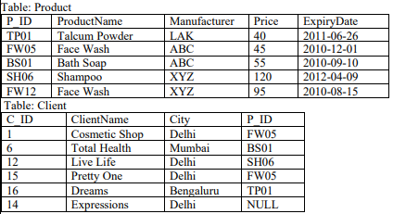  - SELECT Manufacturer, max(Price) FROM Product GROUP BY Manufacturer;  - SELECT P.ProductName, C.ClientName FROM Product P ,Client C WHERE  P.P_ID=C.P_ID AND C.City=’Delhi’;  - SELECT MAX(Expirydate) , MIN(price) FROM Product;  - SELECT P.P_ID, P.Expirydate,C.C_ID from Product P, Client CWHERE  P.P_ID=C.P_ID AND P.price > 55; |  | 2
13 | Write the output for SQL queries (i) to (iv), which are based on the table: CAR  given below:  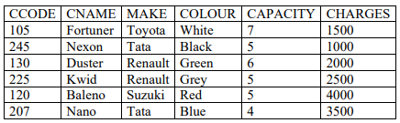  - SELECT DISTINCT MAKE FROM CAR;  - SELECT MAKE, COUNT(*) FROM CAR WHERE MAKE IN (‘Renault’,’Tata’) GROUP BY MAKE;  - SELECT CNAME FROM CAR WHERE CAPACITY>5 ORDER BY CNAME;  - SELECT CNAME, MAKE FROM CAR WHERE CHARGES>2500; |  | 2
14 | Consider the following table Applicants and Centre  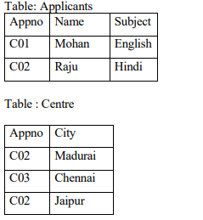  What will be the output of the following statement and also specify the degree and cardinality of the following query.  Select * from Applicants natural join Centre; |  | 2
15 | Give the output of the below code.  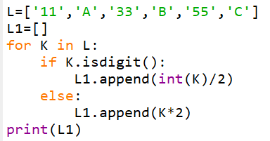 |  | 2
16 | - Consider the following dictionary  Book={1:2,2:3,3:4,4:5}  Rahul executes statement  print(2 in Book)  Assertion (A) : For the above dictionary Book, output of the expression 2 in Book is True  Reason (R) : For dictionary , the in and not in opertors return True or False according to whether the specifie=d operand occurs as a value in the dictionary  Based on the above discussion, choose the appropriate option  a) A is False but R is True  b) Both A and R are True and R is the correct explanation of A  c) Both A and R are True and R is not the correct explanation for A  d) A is True but R is False  e) Both A and R are False  b) Madhur has written a Python code. His code is having errors. Rewrite the correct code and  underline the corrections made.  T=(10,2,’5’,8,3)  X=sorted(T)  X[0]=-5  T.append(30)  print(T) |  | 2
17. | - Given the Python string declaration, print the output  Msg=”HELLO WORLD"  print(Msg[:2],Msg[:-2],Msg[-2:])  - Write the output of the following code given below:  Arr=[1,2,3,4,5,6]  for I in range(1,6):  Arr[I-1]=Arr[I]  for I in range(0,6,2):  print(Arr[I],’!’,sep=’%’,end=’#’) |  | 2
18. | Differentiate between IN and BETWEEN-AND operator ,giving appropriate examples. |  | 2
19. | Write a program in python to put all the duplicate elements to duplicate list and unique element to unique list.  For example if the list is [10,20,30,20,40,50,10,60]  Then the  Duplicate List=[10,20]  Unique List=[30,40,50,60] |  | 3
 | SECTION – C
20. | Consider the table Celebrity  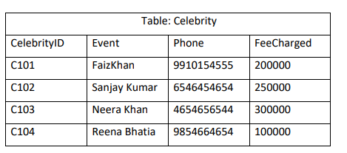  Based on the data given above answer the following questions:  - Identify the most appropriate columns which can be considered as Candidate keys  - If one column is added and 3 rows are deleted from the table result, what will be the new degree and cardinality of the above table?  - Write the statements to:  - Insert a new row with appropriate data  - Increase Feecahrged of all the celebrity by 2000 where the phone contains ‘6’  - Display the event and Annual Feecharged from celebtrity where Feecharged is assumed to be paid by every month  - Add a column grade in the table Celebrity of one character  - Delete the table Celebrity |  | 7
***

